Controlled Substance Operational Plan

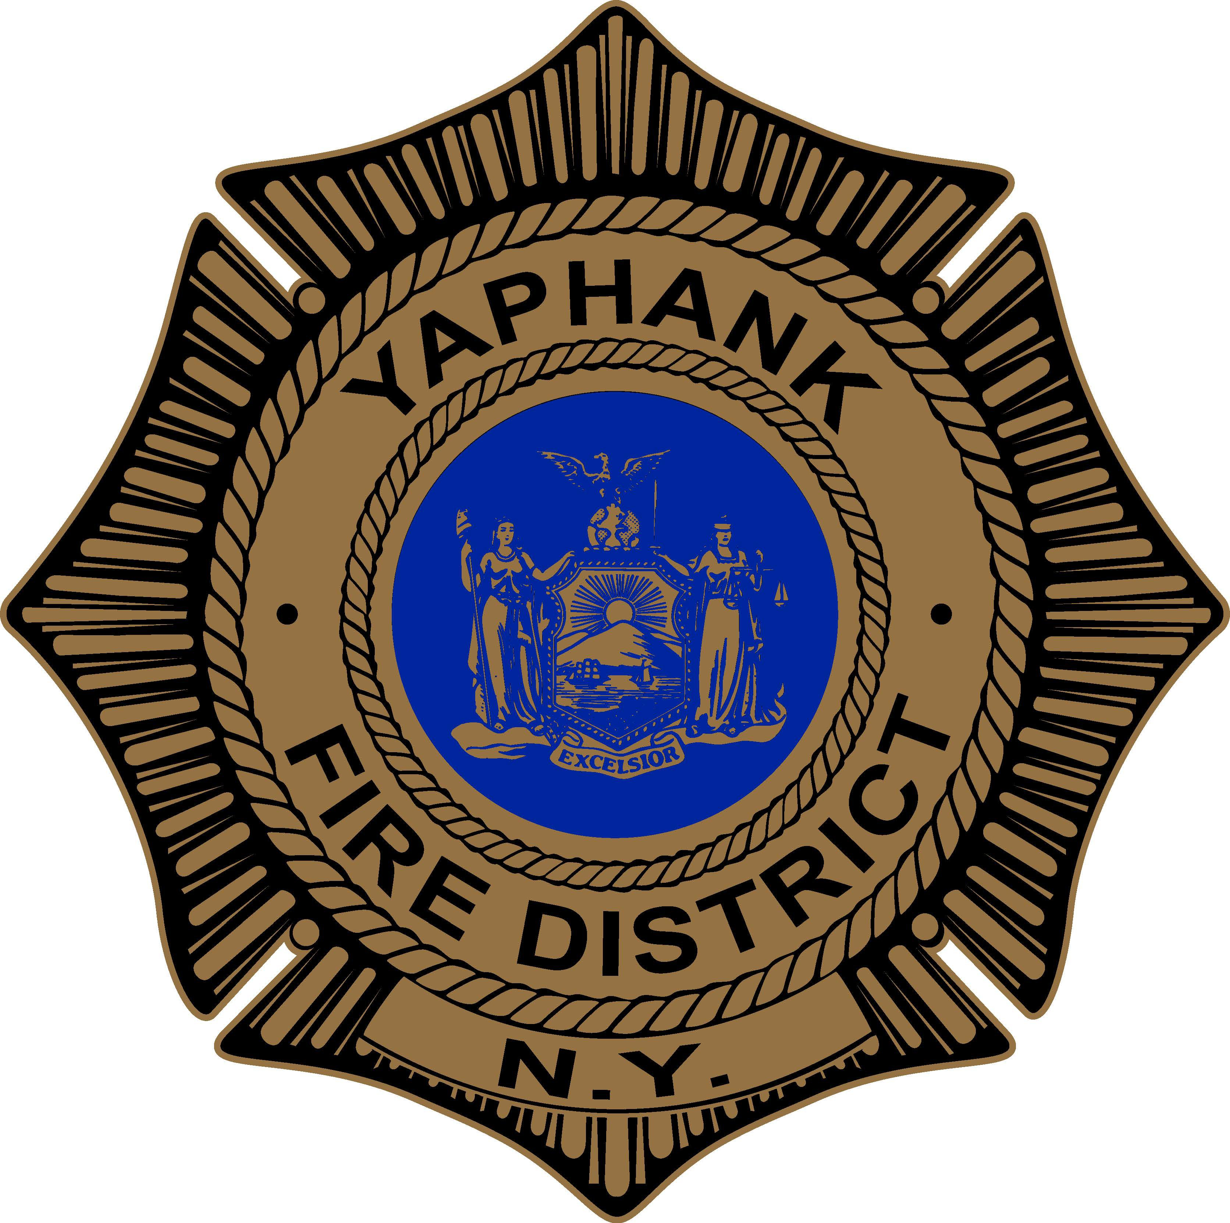

Yaphank Fire District

31 Main Street
Yaphank, NY 11980

TABLE OF CONTENTS

Personnel - Duties & Responsibilities

All Members/Employees Agency Medical Director Controlled Substance Agent
Alternate Controlled Substance Agent Certified & Authorized Members Chief Executive Officer
Advanced Life Support Provider Roster

Storage of and Access to Controlled Substances

Stock of Controlled Substances Sub-stocks in Vehicles Environmental Concerns Department of Health Access
Theft, Loss, Diversion or Security Breech Vehicle Breakdown or Vehicle Out-Of-Service

Record Keeping - FORMS for usage and tracking

Receiving of Initial & Replacement stock Distribution to Vehicle Sub-stocks Removal from Sub-stock
Patient Administration/Partial Dosage Destruction Theft & Loss
Biannual Inventory
Controlled Substance Usage Verification Inventory Verification
Access to the Controlled Substance Storage Locker

Procedures

Obtaining Controlled Substances Source and Packaging Quantities of Sub-stocks
Administration of Controlled Substances On Line Protocols
Designated Physicians
Controlled Substances in Private Vehicles Notification of Change of Agent or Chief / CEO
Disposal of Partial Dosages and Opened/Unused Controlled Substances Signature Pages

PERSONNEL - DUTIES & RESPONSIBILITIES
All members and employees of the Yaphank Fire District will be responsible to report to the District Manager and to the Controlled Substance Agent any loss or theft of a controlled substance and to complete DOH 2094 (Loss of Controlled Substance Report). The Controlled Substance Agent will report to the Agency and System Medical Director any loss or theft of a controlled substance. Each member and employee will acknowledge responsibility of this requirement in writing on a form provided by the Yaphank Fire District

The Yaphank Fire District has as its Agency Medical Director designated
Dr. Jerry Rubano, M.D.

Agency Medical Director: The responsibilities of the Agency Medical Director, Dr. Jerry Rubano, include, but are not limited to, the following:
  - Be responsible for medical oversight regarding the use of controlled substances in the protocols approved by the Suffolk REMAC, the System Medical Director and the NYS Department of Health. A copy of each approved protocol is attached. The NYS Department of Health must approve any change in these protocols prior to being implemented.
  - Be accountable for the proper use and administration of controlled substances by receiving a copy of the patient EPCR within 24 hours of the administration of a controlled substance.
  - Meet, at least quarterly, with the ALS providers of this Agency for the purpose of Call Review and Continuing Education.
  - Supervise any required re-education and/or re-training of any ALS providers of this Agency relating to the use of controlled substances.

Controlled Substance Agent: The Yaphank Fire District will appoint an ALS provider as its Agent for Controlled Substances. The agency CEO or other executive as approved by the Yaphank Fire District will appoint the Agent.

The Controlled Substance Agent responsibilities include, but are not limited to, the following:

- Obtaining the controlled substances such as morphine, fentanyl, and midazolam from Long Island Community Hospital, as per the written agreement. The CSA will transport all controlled substances between the hospital and the Yaphank Fire District in a Yaphank Fire District vehicle.

- The CSA will document and secure all controlled substances in the main safe and restock the sub-stocks which will be on the providers’ person (when on duty) or in the ambulance/securement safe. Controlled substance sub-stocks in the Yaphank Fire District will be maintained in a sealed case with a numbered security tag. This case will be maintained on the providers’ person, when on duty as the First Responder, or in the designated sub-stock safe. In the event that a provider is unable to transfer the sealed case to the oncoming responder: The sealed case will be secured in the safe permanently affixed to the main ALS locker in the EMS office.

- The CSA will maintain, update, and file the following forms:
Controlled Substances Log is used by the Controlled Substance Agent to record the controlled substance medication delivered to the ALS agency.

The Controlled Substances Restock Log is designed to record distribution of controlled substances from the agency stock to one or more agency CS Packs as sub-stocks and record the administration of the controlled substance medication. Separate logs will be maintained for each controlled substance. These records will be maintained by the agency for a minimum of five (5) years. The Controlled Substances Usage Log and DOH 3850 is used to document administration and waste of controlled substances for submission to the Hospital for the purpose of inventory balance and control during the period prescribed by the operations plan.

Loss of Controlled Substance: (DOH 2094) is designed to record the loss or theft of any controlled substance which must be reported to the state. The Controlled Substance Agent is responsible to insure completion of that form. Any ALS provider or any other member or employee of the Agency that becomes aware of a loss or theft of a controlled substance must report the loss/theft to the District Manager, Chairman of the Board and CSA. This form shall be submitted to both the NYS-DOH EMS Office and the System Medical Director. These forms will be maintained by the Agency for a minimum of five (5) years. If appropriate, the local law enforcement agency under whose jurisdiction the loss, theft, or diversion occurred may also be contacted.

The Controlled Substances Biannual Report DOH-3848 will document the ongoing status of the Agency's controlled substance inventory. The report will be submitted to the Bureau of Controlled Substances, the DOH EMS Program (MARO), and the System Medical Director twice a year. It will be submitted within 30 days of June 30th and December 31st of each year. This form will be maintained by the agency for a minimum of five (5) years.

- Verify at least monthly, the validity of the current inventory for each controlled substance in each stock and sub-stock, being cognizant of both numbers and the integrity of packaging and security seals, using the control substance logs to document the audit. In the event that a provider is unable to transfer the sealed case to the oncoming First Responder, the CS Pack will be secured in the agency Transfer/Securement SAFE and recorded on Transfer/Securement Log.

- Issue to authorized ALS providers of the Yaphank Fire District, a PIN number and fingerprint access to the Ambulance Safe and Main Transfer/Securement Safe.

- Submit to the NYS Department of Health for review, modification and/or approval of any changes to this Operational Plan or the Agency's Quality Assurance (QA) Plan. This will include any change to the location of all stock and sub-stocks, the safeguarding of the Control Substances, access to and security standards for all controlled substances. Ensure that authorized representatives of the NYS Department of Health will have access to all controlled substance stock and sub-stocks for inspection.

Alternate Controlled Substance Agent:

- Be a member or employee of the Yaphank Fire District, an ALS provider, and be designated as "Alternate Controlled Substance Agent" by the CEO of the Agency. The CEO may not be appointed as the "Alternate Controlled Substance Agent ".
- Be authorized by Yaphank Fire District to act as the Controlled Substance Agent during the absence of the Controlled Substance Agent.
- Act only after receiving as the CSA designee when the CSA is not available.
- Assume the same duties and responsibilities as the Controlled Substance Agent while functioning in his/her temporary absence.

Certified & Authorized Individuals (ALS providers) will:

- Be a currently certified EMT-CC or EMT-P who has been authorized by the District Manager, the Controlled Substance Agent of the Yaphank Fire District and both the Agency and System Medical Directors to properly administer controlled substances under a physician’s order or per regional protocols.
- Be responsible for safeguarding and handling of controlled substances during and following any call and assuring that only certified and authorized individuals are permitted to access, and/or handle, controlled substances.
- Be cognizant of patients or others in the ambulance that may have reason to steal or divert controlled substances.
- Notify the Controlled Substance Agent, District Manager and Agency Medical Director
of all uses, disposal, loss, or theft of controlled substances.
- Be responsible for completing the Controlled Substances Transfer/Securement Log; the Pre-hospital Care Report (PCR) and waste signature form for each administration or distribution of a controlled substance; and DOH 2094 (Loss of Controlled Substance Report) if required.
- Report to the District Manager and Controlled Substance Agent any loss or theft of controlled substance or access codes/keys immediately upon discovery of the loss or theft.
- Receive and read the Yaphank Fire District Controlled Substance Operational and Quality Assurance Plans and acknowledge same on a form provided by the Yaphank Fire District.

The Agency CEO will be ultimately responsible for:

- Ensuring that all required reporting forms and submissions are completed in a timely manner and submitted to the appropriate entity, i.e., System Medical Director, Agency Medical Director, New York State Department of Health, Police Department, etc.

- The Agency CEO shall not be relieved from any responsibility under Part 80 or the Operational and Quality Assurance Plans as a result of any delegation of responsibility.

STORAGE OF AND ACCESS TO CONTROLLED SUBSTANCES
All controlled substances obtained from Long Island Community Hospital will be logged on DOH 3850 and placed in the Yaphank Fire District CS Packs and secured in the appropriate Safe. The Transfer/Securement Safe is permanently affixed in the ALS locker in the EMS room of the Yaphank Fire District. Each Yaphank Fire District Ambulance also contains a Safe for one CS Pack Storage.

Sub-stock is the CS Packs numbered 1-5

There will be five CS Packs, each sealed with a security tag. One CS Pack will be maintained on the person of the First Responder on duty and one pack will be maintained in each safe on the Yaphank Fire District Ambulances (5-30-16 and 5-30-17). The remaining two packs will be kept in the Transfer/Securement Safe in the ALS Locker in the EMS Office of Yaphank Fire District.

Access to CS Packs will be limited to authorized and certified members or employees of the Yaphank Fire District. Each certified and authorized individual will acknowledge, on a form provided by the Yaphank Fire District, receipt of a controlled substance access PIN and fingerprint ID for access to the Narcotics Safes.

Any time the numbered seal on a CS Pack is broken, a Certified and Authorized individual shall, in the presence of a witness (when possible and who shall be a member of the Yaphank Fire District) re-inventory the contents of the pack and attach a new numbered seal. The new inventory and new seal number shall be documented, and the documentation signed by the provider on the Control Substance Seal tracking form. Each usage will be documented in the Controlled Substance Usage Log.

Environmental Concerns

All Controlled Substances will be stored to protect them from extreme temperatures, including freezing and overheating. The temperature shall remain between 59- and 77-degrees Fahrenheit to prevent deterioration of the controlled substances in storage. When there is no First Responder on duty, the CS Pack will be secured and stored in the steel, permanently affixed, locked safe/cabinet at the Yaphank Fire District to which only authorized and certified individuals have access to. When the first responder is on duty, the authorized individual must carry the controlled substances in a sealed pouch on their person.

Department of Health Access

An authorized representative of the NYS Department of Health shall have access to all controlled substances and records pertaining to controlled substances as required by Part 80 of the New York State Code of Rules & Regulations. The individual representing the NYS Department of Health shall be appropriately credentialed with proper photo ID.

Theft, Loss, Diversion or Security Breech Relative to a Controlled Substance.

Any member or employee of the Yaphank Fire District who becomes aware of the theft, loss, diversion, or a security breech relating to a controlled substance shall immediately notify the Yaphank Fire District Controlled Substance Agent and the District Manager and complete the DOH-2094 form.
The Controlled Substance Agent shall immediately notify the NYS Department of Health's Bureau of Controlled Substances, Emergency Medical Services Program; and the Agency and System Medical Directors, Suffolk County EMS, and forward a completed copy of the DOH-2094 form to each.
The control substance agent shall be responsible to document, whenever possible, the specific circumstances of the theft, loss, diversion, or security breech.

Vehicle Breakdown or Vehicle Out-Of-Service

Yaphank Fire District does not permit a personal vehicle to carry controlled substances. If a vehicle breaks down, or is taken out of service for any reason, the CS Pack shall be removed from the Ambulance safe and stored in the Transfer/ Securement Safe at YFD. When an employee is injured or ill and will not return to duty, the Controlled Substance Agent, or his/her designee, will retrieve and secure the CS Pack in the Yaphank Fire District Transfer/Securement safe. As soon as possible, the Controlled Substance Agent shall inventory the CS Pack and, if not already done, notify the District Manager that the CS Pouch was transferred from the provider into the Yaphank Fire District Transfer/Securement safe.

RECORDKEEPING - FORMS FOR USAGE AND TRACKING OF CONTROLLED SUBSTANCES

Tracking Forms used by the Yaphank Fire District
Chart 1 - Controlled Substance Transfer/Securement Log
Chart 2 - Control Substance Seal Tracking Log Chart 3 - Controlled Substance Usage Log

Letter Forms to be used by the Yaphank Fire District
YFD CS form #1 - Controlled Substance Program – Agency Medical Director
YFD CS form #2 - Controlled Substance Program – Receipt of PIN and Fingerprint ID for YFD Narcotics Safes
YFD CS form #3 - Controlled Substance Program – Receipt of Policy and Procedures
YFD CS form #4 - Controlled Substance Program – Acknowledgement of Responsibility Member/Employee

NYS DOH Forms to be used by the Yaphank Fire District
DOH 2094 (Loss of Controlled Substance Report) “Loss of Controlled Substances” -Suspected Diversion DOH-3848
“Controlled Substances Biannual Report”
DOH-3827
“Application to be a Controlled Substance Agent for an ALS Agency”
DOH-3850
“Stock Log”
DOH-3851
“Sub-Stock”
DOH-4004
“Controlled Substance Usage Log”
All records pertaining to controlled substances will be stored in a locked file at:

Yaphank Fire District
31 Main Street, Yaphank N.Y. 11980

PROCEDURES
OBTAINING CONTROLLED SUBSTANCES:
Source
The Yaphank Fire District will obtain all controlled substances from the Pharmacy at Long Island Community Hospital. A copy of the executed written agreement between Yaphank Fire District and St. Charles Hospital and John T. Mather Memorial Hospital is attached. The only controlled substances, which may be obtained by the Yaphank Fire District, are Fentanyl, Midazolam, and Morphine.

Packaging
The packaging of the controlled substances will be as follows:

Morphine Sulfate: 10 mg vials containing 10 mg/mL, 1 mL fill Midazolam: 5 mg vials containing 1mg/mL, 1 mL fill Fentanyl: 100 mcg vials containing 50mcg/mL, 2 mL fill

QUANTITIES OF STOCK & SUBSTOCK
The INITIAL STOCK of all five CS Sub-stock Packs:

Morphine Sulfate: ten (10) vials containing 10 mg / 1 ml Midazolam: twenty (20) vials containing 5 mg / 1 ml Fentanyl: ten (10) vials containing 100 mcg/ 2mL

A request to the hospital for initial stock of controlled substances will be recorded on form CONTROLLED SUBSTANCE DOH-3850. Only the controlled substance Agent or Authorized Alternate will be permitted to receive controlled substances from the source hospital. The stock will be replenished on a 1:1 exchange to re-stock sub-stocks. The transport of all controlled substances between the hospital and the Yaphank Fire District shall be in a locked case such as not to call attention to its content as something of value and transported in a Yaphank Fire District vehicle.

SUB-STOCK, also known as the CS Pack, the first responder carries on their person and each Yaphank Fire. District Ambulance carries one CS pack in the affixed Narcotics safe.

Agencies will be required to ID each Certified and Authorized member or employee authorized by the DOH to carry Controlled Substances. No other vehicles will be allowed to transport Controlled Substances under routine circumstances.
Initial quantities of controlled substances will be provided for each Certified and Authorized member or employee in the “CS Pack”.

Each narcotic pack will contain:
Morphine Sulfate: Two (2) vials 10 mg in 1 mL fill Fentanyl: Two (2) vials containing 100 mcg in 2 mL fill Midazolam: Four (4) vials conatining 5 mg in 1 mL fill

The Controlled Substance Agent will be responsible to replenish sub-stocks as controlled substances are used and as soon as practical. A request to the hospital for replacement of controlled substances will be accompanied by form-controlled substance restock log documenting usage of the medications when levels near or fall below 40%. Only the Controlled Substance Agent will be permitted to receive controlled substances from the source hospital. Transport of all controlled substances between the hospital and the Yaphank Fire District shall be in an unobtrusive locked case such as not to call attention to its content as something of value and transported in a Yaphank Fire District vehicle.

ADMINISTRATION OF CONTROLLED SUBSTANCES

On-line Protocols

Controlled substances will only be administered by an Authorized and Certified member or employee of the Yaphank Fire District in accordance with on-line Medical Control protocols (see attached) and only when ordered to do so by a designated physician.

Designated Physicians

- On-line Medical Control Physician - authorized by the REMAC and the System Medical Director to provide advice and direction to ALS providers providing out-of-hospital medical care, or

- Medical Control Field Physician - authorized by the REMAC and the System Medical Director to provide advice and direction when such physician is present at the scene of an out-of-hospital emergency.

A Certified and Authorized individual making any administration of a controlled substance pursuant to the order of a designated physician shall notify Medical Control to make a record of the administration during or immediately following the run.

Each Certified and Authorized individual receiving an order to administer a controlled substance will make a record of the administration. This record shall be made in the NYS Department of Health's Pre-Hospital Care Report and Continuation Form. A copy of the Pre-hospital Care Report and the Continuation Form shall become part of the patient's hospital record. Patient confidentiality shall be maintained at all times. A copy of the Pre-Hospital Care Report and the Continuation Form must be returned to the Controlled Substance Agent before any controlled substances sub-stock can be replenished any QA/QI form as well required by Yaphank Fire District.

CONTROLLED SUBSTANCE IN PRIVATE VEHICLES

No member or employee of the Yaphank Fire District will be permitted to carry any controlled substance in his/her private vehicle(s).

NOTIFICATION OF CHANGE OF CONTROLLED SUBSTANCE AGENT OR CHIEF/ CEO

The CEO/ Agent of the Yaphank Fire District will immediately notify NYS BEMS and the New York State Department of Health EMS Program Area Office when their Controlled Substance Agent or Chief/ CEO are changed. The name of the alternate Controlled Substance Agent will be reported to the BCS at that time. The alternate Controlled Substance Agent will function until a new Controlled Substance Agent is approved through submission of DOH-3827.

DISPOSAL OF PARTIAL DOSAGES AND OPENED/UNUSED CONTROLLED SUBSTANCES

Partial dosages remaining after the administration of a unit dose of a controlled substance will be destroyed and properly disposed of provided that:

- The destruction is witnessed by a provider of the Yaphank Fire District or hospital staff if available.

- Documentation will be made on the EPCR Narcotics form by name, title, and signature of the witness and Control Substance Seal Tracking by the Certified and Authorized individual.

- An entry will be made in the CONTROLLED SUBSTANCE USAGE LOG to account for the change in the CS Pack balance. The CS lot number shall be documented on the ePCR and usage log.

SIGNATURE PAGE 1
Yaphank Fire District Endorsements

I have read the Controlled Substance Operational and Quality Assurance Plans of the YFD and agree to the terms and conditions set forth.

CEO (Print) Signature Date

__________________________ __________________________________
CS Agent Signature Date

SIGNATURE PAGE 2
Yaphank Fire District
Medical Director(s) Endorsements

I have read the Controlled Substance Operational and Quality Assurance Plans of the YFD and agree to the terms and conditions set forth.

Jerry Rubano, M.D.
Agency Medical Director (Print)
Signature Date

Yaphank Fire District
31 Main Street
Yaphank, N.Y. 11980

Tracking Forms to be used by the Yaphank Fire District

Chart 1 - “Controlled Substance Transfer/Securement Log” for crews. Chart 2 - "Controlled Substance Seal Tracking Log" for crews.
Chart 3 - “Controlled Substance Usage Log” for crews.

Letter Forms to be used by the Yaphank Fire District

"Acknowledgment of Responsibility"
To be signed by all members/employees of the Yaphank Fire District

"Receipt of Controlled Substance SAFE access PIN and Fingerprint ID"
To be signed by all certified/authorized individuals receiving such PINS of the Yaphank
Fire District

"Receipt of Yaphank Fire District Controlled Substance Procedures”
To be signed by all certified/authorized individuals providing ALS care for the Yaphank
Fire District

“Agency Medical Director Agreement”
Yaphank Fire District

NYS DOH Forms to be used by the Yaphank Fire District

DOH 2094 (Loss of Controlled Substance Report) “Loss of Controlled Substances” -Suspected Diversion DOH-3848
“Controlled Substances Biannual Report”
DOH-3827
“Application to be a Controlled Substance Agent for an ALS Agency”

Yaphank Fire District
31 Main Street
Yaphank, N.Y. 11980

Controlled Substance Program –

AGENCY MEDICAL DIRECTOR AGREEMENT

I acknowledge receipt of the Yaphank Fire District Controlled Substance Operational & Quality Assurance Plans.
I have read these plans and I am familiar with their content.

I agree to accept all responsibilities defined in these plans which are incumbent upon the Agency Medical Director for the Yaphank Fire District.

Print Name / DEA License Number Signature

Date:

Copy file: employee file/YFD CS form #1

Yaphank Fire District
31 Main Street
Yaphank, N.Y. 11980

Controlled Substance Program –
Receipt of Access Code(s) and Fingerprint ID for Transfer/Securement SAFE.

I, , acknowledge receipt of the necessary access code and fingerprint ID that will provide me access to the transfer/securement SAFE for securing controlled substances assigned to me while on duty at the Yaphank Fire District.
I acknowledge my responsibility to safeguard the Electronic Codes and to permit no other person to use it. In addition, I agree to return all keys/codes, procedures and policy manuals that provide access to controlled substances to the District Manager or the Controlled Substances Agent upon their request or upon my separation from Yaphank Fire District. I also agree to notify Suffolk Country, Chief of Training and Education of my loss of affiliation and revocation of control substances administration privileges.

Print Name / Level of Certification / Number Signature Date:

The date the Keys/Codes returned or reported lost or stolen:

Copy file: employee file/YFD CS form #2

Yaphank Fire District
31 Main Street
Yaphank, N.Y. 11980

Controlled Substance Program – Receipt of Policy and Procedures

I, , acknowledge receipt of the Yaphank Fire District Controlled Substance Operational & Quality Assurance Plans.
I have read these plans and I am familiar with their content.

I agree to accept all of the responsibilities and comply with the policies and procedures as defined in these plans as an employee of the Yaphank Fire District who administers controlled substances while on duty.

Print Name / Level of Certification / Number Signature

Date:

Copy file: employee file/YFD CS form #3

Yaphank Fire District
31 Main Street
Yaphank N.Y. 11980

Controlled Substance Program – Acknowledgement of Responsibility

I, , acknowledge my responsibility as a Member/Employee of the Yaphank Fire District to immediately report any loss or theft of any Controlled Substance to the District Manager. When the District Manager is not immediately available, please contact the Chairman of the Board, and/or the Controlled Substance Agent.
The district is required to complete NYS form DOH 2094 (Loss of Controlled Substance) and follow the procedures for the reporting actual or perceived loss or theft of narcotics stored in the district office for the purposes of providing ALS services in the YFD.

Print Name / Rank Signature and Date

Copy file: employee file/YFD CS form #4

THIS PAGE HAS BEEN LEFT INTENTIONALLY BLANK.

